***Horse head statue***

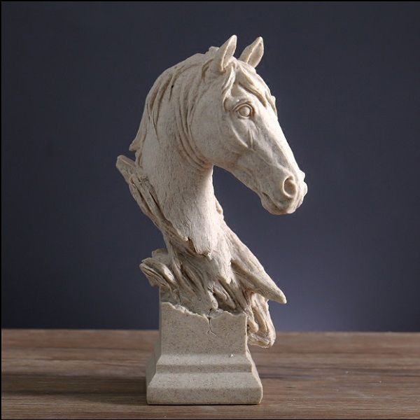

*The horse head statue is made of artificial stone, ivory white. The statue has a unique meaning of success. The product is suitable for interior decoration, housewarming gift, boss gift or teacher gift, .*